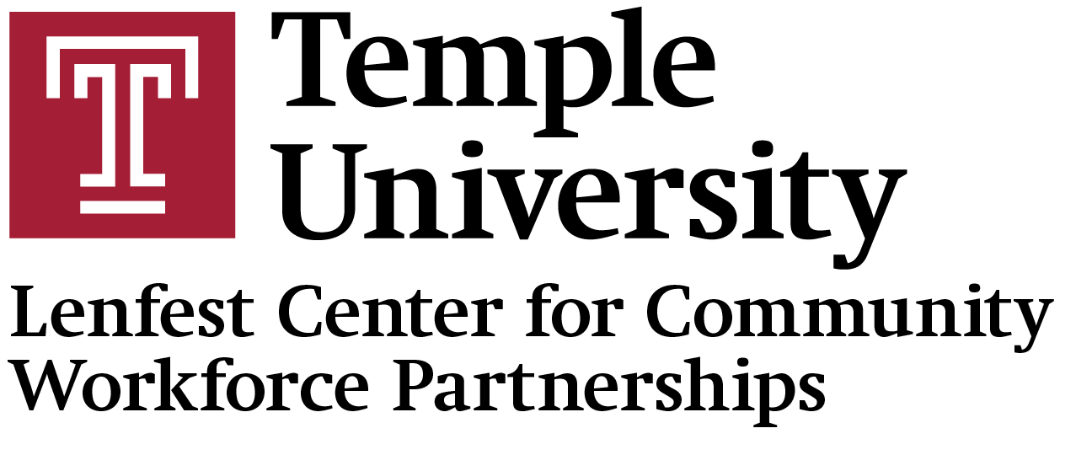

19th Annual Neighborhood Job Fair and Resource Village

Employer and Resource List
AppleOne | Intealth | Philadelphia Marriott Downtown
Aramark Heallthcare | Jefferson Health | Philadelphia Police Recruiting Unit
ATC/Carebuilders at Home | Jefferson Health | Philadelphia Sheriff Office
CareerLink West Philadelphia | JEVS Care at Home | Philadelphia Water Department
Carelink Community Services | JEVS Human Services | Philadelphia Technician Training Institute (PTTI)
Carr & Duff LLC | KenCrest | Pine View Healthcare
Catch Inc. | Kimpton Monaco Hotel | Primerica Financial Services
Children's Hospoital of Philadelphia | Lincoln Heritage/Stenhaus Insurance Group | Public Health Management Corporation
City of Philadelphia Office of Human Resources | Martin Brower | Rivers Casino
City of Philadelphia Office Of Innovation and Technology | Mazzoni Center | SEPTA
Commonwealth of PA | Mendoza Group/Pennie | Somerset Academy Early Learning
Community Integrated Services | Mental Health Partnerships | SpArc Philadelphia
Congreso de Latinos Unidos, Inc. | Metal Powder Group | Supportive Behavioral Resources
CORA Services, Inc | Montgomery County Pa | SVJ Insurance Advisors Inc
Courage Medicine | Moravia Health | Temple Army ROTC
Councilmember Jeffery Young Jr's Office | My Independence at Home | Temple Department of Public Safety
Delta T Group | New York Life Insurance Company | Temple Human Resource Office
Dress For Sucess Greater Philadelphia | Oasis Heal Solutions | Temple University Gateway
Destiny HomeCare | Office of Vocational Rehabilitation(0VR) | The First Judicial District of PA
Dunbar Wellness Group Inc | Open Arms Home Care | The Logan Hotel
Elliott-Lewis Corporation | PA CareerLink | The School District of Philadelphia
Empower Work | PAHrtners Deaf Services | The Franklin Institute
EMR | Pampering Plus Inc | The Welcoming Center
Evolution US LLC | PA State Police Liquor Enforcement/PA State Police | TRT Cleaning Services Inc.
Friends Hospital | Penn Dot | Urban League of Greater Philadelphia
Fulton Bank | Petey Greene Program | Urban Technology Project
Gateway Community Action Partnership | Philadelphia Corporation for Aging | Wonderspring
Gift of Life Donor Program | Philadelphia Department of Prisons | Woods System of Care
Graduate Philadelphia | Philadelphia Federal Credit Union | WSFS Bank
Independence Blue Cross | Philadelphia Fire Department | Xiente
Independence Rehab and Nursing | Philadelphia Gas Works

